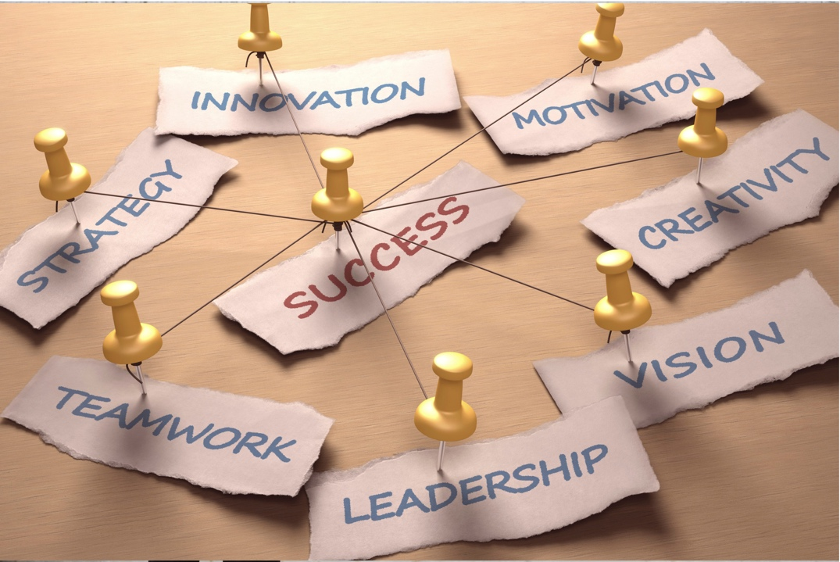

Rebuild • Reenergize:
A Webinar Series for Business Leaders in a Post COVID World

Join us for this series of five monthly webinars to receive helpful and practical tools to navigate the new normal. Experts in their fields will show you all you need to know – from legal considerations to best practices in digital advertising; from brand identity to effective sales techniques; from actionable advice on marketing and communication best practices to help your small business succeed in 2021 and beyond.
This series is a partnership with chambers of commerce throughout Illinois.

You may register for the series as a whole or register for each webinar individually.
Each webinar is $15.

Return to Work: How to Navigate the Transition Successfully
9:00 -10:30 a.m. Wednesday, April 21, 2021

As vaccines become more readily available, employers are bringing more and more of their workforce back to the office. This transition comes with its own host of challenges. This presentation will give employers the most up to date information regarding evolving issues including OSHA safety requirements, CDC and vaccine guidance, as well as the challenge of how to deal with employees that refuse, have medical reasons or/are uncomfortable with returning to work. This presentation is essential to ensure that the transition moves smoothly, safely and in a compliant manner.

Julie Proscia
Labor and Employment Practice Group-Partner
SmithAmundsen, LLC

Julie Proscia provides labor and employment counsel that is outcome based. Before giving advice, she asks her clients what they want or need as the outcome to their matter; then skillfully crafts a pragmatic, business-centric solution to the issue.

Julie actively navigates employers of all shapes and sizes through the legal pitfalls of the employment relationship from its inception at recruitment and hiring through the implementation of policies and procedures, and the conclusion of the relationship with the termination/separation process. When litigation becomes necessary, Julie aggressively advocates for clients in the areas of traditional labor and employment law, including but not limited to discrimination/retaliation cases, non-competition/non-solicitation enforcement, wage and hour litigation, and employment and labor arbitrations.

Finally, in addition to, and in concert with, her labor and employment practice, Julie assists a substantial number of not-for-profits with both their traditional employment issues, as well as the issues that arise before 501(c)(3) and 501 (c)(6) organizations. Julie’s not-for-profit practice includes training in board policies, procedures, and development, as well as counseling a defense.

How COVID Helped A New Coffee Shop Succeed
Presented by Ryan Weckerly, Morningstar Media Group
9:00 – 10:00 a.m. Wednesday, May 19, 2021

Six months before COVID-19, Ryan and Karen Weckerly opened a coffee roastery. Then March 2020 hit. Join Ryan as he discusses how he and his wife Karen used technology, social media, and Amazon to pivot their business model. What was initially planned as an in-house coffee roaster and tasting experience, with limited retail hours and only for small groups turned quickly into a full-scale retail destination, featuring a full menu of custom drinks and roasted coffees, available seven-days-a-week via contactless curbside pickup at a custom-built outdoor kiosk. Learn more about how Ryan and Karen continued to build their new business with online retail sales, all while creating an experience for local patrons through a new, greatly expanded retail storefront and Coffee Bar.

Attendees will learn:
- To adapt business models utilizing technology and social media
- How to successfully pivot with significantly reduced revenue
- A quick view into utilizing online retail outlets
- How to leverage social media to create new fans and brand loyal followers with examples of organic and paid social strategies
- How COVID-19 continues to change the retail landscape, and how a pandemic helped us think creatively and succeed
Ryan Weckerly
Morningstar Media Group
rweckerly@morningstarmediagroup.com

As president of MorningStar Media Group, he has built an extensive clientele base. Ryan has seen clients through crisis and economic downturns by creating strategic campaigns that stand the test of time. Ryan holds a Bachelor of Arts in Mass Communications with an emphasis in Media Science and Consumer Behaviors from Southern Illinois University, and he didn’t stop there. Continuing education is an important part of Ryan’s career. He frequently attends web development and marketing seminars to stay on top of ever-evolving trends, and does continual studies on search engine optimization. While Ryan seeks out any chance to gain the latest knowledge, he also a selected member of the Forbes Agency Council, where he regularly publishes his insights and best practices on marketing strategy and communications. You can also find Ryan on the national speaking circuit covering social media, internet marketing, and website development.
Crucial Business Components to Success
Presented by Amanda Brinkman/Small Business Revolution
9:00 – 10:00 a.m. Wednesday, June 16, 2021
Amanda will share the lessons learned in working with small businesses across the country, offering the audience actionable advice on marketing and communication best practices. Often small businesses feel they can’t afford the time or fiscal investment in marketing, but Amanda is often quoted saying small businesses can’t afford to NOT to invest in marketing.

She will share insights of the most important focus areas of your brand and digital footprint, sharing case studies from real businesses featured in the Small Business Revolution series.
More information, including the first 5 seasons of the Small Business Revolution, can be found at smallbusinessrevolution.org.

Amanda Brinkman
Small Business Revolution
https://www.amandakbrinkman.com/
amandabrinkman@gmail.com

Amanda Brinkman is the creator, producer and host of the hit series “Small Business Revolution,” which streams on Hulu and Prime Video and was named among Inc. Magazine’s top shows for entrepreneurs. Now in production of their 6th season, each year the Small Business Revolution revitalizes a different community’s “Main Street” through small business makeovers. Every episode they help work to help the entrepreneur with marketing, finance, operations and physical transformations of their space.

The Art of Pivoting: Strategies for Developing a Flexible Business Model for the Future
Presented by Julie Shields, President/CEO, USASBE
9:00 – 10:00 a.m. Wednesday, July 21, 2021

The COVID-19 Pandemic has caused changes to business models in every industry. Learn how three business owners pivoted to extend their brand identity using technology and social media. Listening to customer's wants and needs has never been so important. The discussion will include how to use data to make your next move. This session will include time for Q&A on how you can apply these concepts to your specific industry.

Takeaways include:
- tips for "listening" to your customer's new behaviors
- identifying customers as key influencers.

Julie Shields
USASBE (United States Association for Small Business & Entrepreneurship)
jshields@usasbe.org

Julienne (Julie) Shields is the President and CEO of the United States Association for Small Business and Entrepreneurship (USASBE) and started in that role in March of 2020 at the beginning of the pandemic. Since that time, she facilitated the transition of the board from an operating board to a governing board, shepherded the organization from its traditional in-person conference to its first virtual conference, and invested in digital and virtual competencies and platforms to prepare for hybrid and additional virtual events in the future. Prior to this role, she was the Director of the Center for Entrepreneurship at Millikin University and an entrepreneur in her own right launching a tech startup out of the University of Illinois Urbana-Champaign’s EnterpriseWorks incubator. When she is not focusing her efforts on USASBE's mission of advancing entrepreneurship education through bold teaching, scholarship, and practice, she raises her four children and operates a Welsh pony conservation program with her husband.

Sales and Marketing to Help You Dominate Your Market
Presented by Bill Guertin – the 800 Pound Gorilla
9:00 – 10:00 a.m. Wednesday, August 18, 2021

What should small businesses be doing in sales and marketing to succeed in the “new” competitive landscape? Bill Guertin is known as “The 800-Pound Gorilla of Sales”, and in this presentation, you’ll learn what’s working NOW in sales and marketing, what’s predicted to work going forward, and what techniques may need to be re-tooled or abandoned altogether. You’ll come away with several specific ideas to increase your business visibility, your brand value, and your bottom line.
Attendees will:
- Better understand the new dynamics of the marketplace, and what is driving buying decisions
- Be able to more effectively use readily available sales and marketing tools to succeed
- Be introduced to brand new tools and techniques to consider in 2021 and beyond

Bill Guertin - the 800 Pound Gorilla
bill@the800poundgorilla.com

Bill Guertin is a sales and marketing authority, a keynote speaker at many conferences and trade shows, a Certified Virtual Speaker, and a lifelong resident of Kankakee County. A 1979 graduate of Bishop McNamara Catholic High School, Bill’s dynamic sales programs are in use at over (100) ticket sales departments of professional sports teams in the US, Canada and Mexico. He is the author of two books on sales and marketing, and is Chief Learning Officer of ISBI 360, a virtual training company that provides industry-specific executive education to the business side of sports and entertainment.

